GSoC’25 Proposal - Keploy

**6. App Dashboard with Metrics and Chart**

[**Prototype Web App**](https://keploy-dashboard-shardendu-mishra-gsoc.vercel.app/) **|** [**Live Demo**](https://www.loom.com/share/dee0f5f41ba242cca0c3e43f1fc198aa?sid=e228765b-fa4b-4f3b-bd79-7a790ad453ad)

## **Personal Details**

## **·** **Name: Shardendu Mishra**

## **·** **Course: Computer Science Engineering**

## **·** **Email: mishrashardendu22@gmail.com**

## **·** **GitHub:** [**MishraShardendu22**](https://github.com/MishraShardendu22)

## **·** **LinkedIn:** [**Shardendu Mishra**](https://www.linkedin.com/in/shardendumishra22/)

## **·** **Phone: +91 8707359576**

## **·** **Current Country: India**

## **Resume:** [**Link to Resume/CV**](https://drive.google.com/file/d/1AiCHH7NoA5BqaigPzavo2zBaq6KphSvT/view?usp=sharing)

**About Me**

**1. Introduction and Development Background**

Hello Mentors, I am Shardendu Mishra, a Computer Science student at IIIT Dharwad. I am a full-stack web developer and lead the Web Development Club at my institute, with extensive experience in building robust web applications.

My expertise includes**:**

* **Frontend:** React.js, Next.js, Tailwind CSS, HTML, CSS, and UI libraries like ShadCN and AceternityUI.
* **Backend:** Node.js and Golang-based backends.
* **Databases:** MongoDB, MySQL, and PostgreSQL.
* **ORMs and ODMs**: Mongoose, Drizzle, and Prisma.

I completed a remote internship at a Sweden-based company, where I developed a full-stack web application for stroke assessment. Additionally, I contributed to my college’s official website, handling both backend and frontend development.

**2. Interest in Keploy**

I am particularly interested in Keploy’s project because it aligns with my tech stack and offers a challenging learning experience. To explore its ecosystem, I developed a prototype for this GSoC Project: [**Keploy Dashboard Prototype**](https://keploy-dashboard-shardendu-mishra-gsoc.vercel.app/) , here is the [**Live Demo**](https://www.loom.com/share/dee0f5f41ba242cca0c3e43f1fc198aa?sid=e228765b-fa4b-4f3b-bd79-7a790ad453ad). This project allowed me to gain hands-on experience with Keploy's framework and understand its potential.

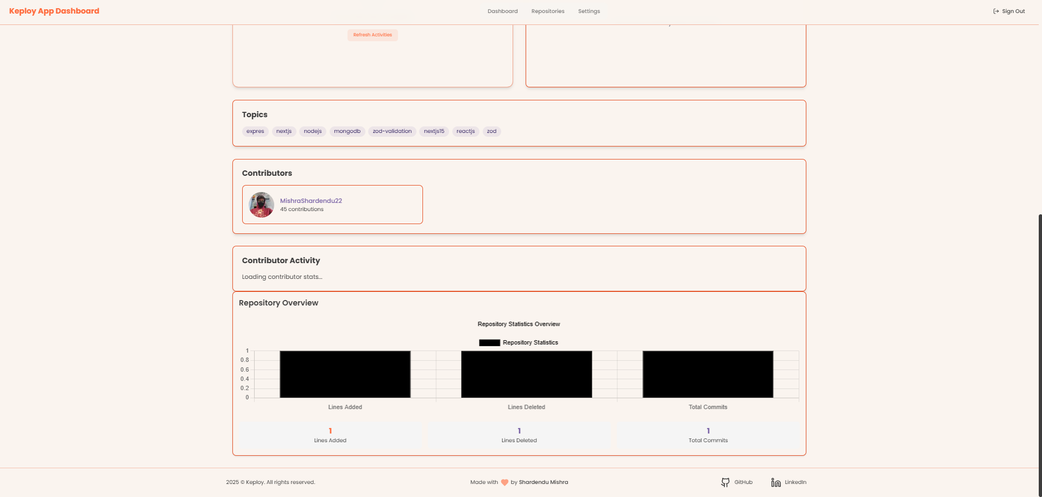 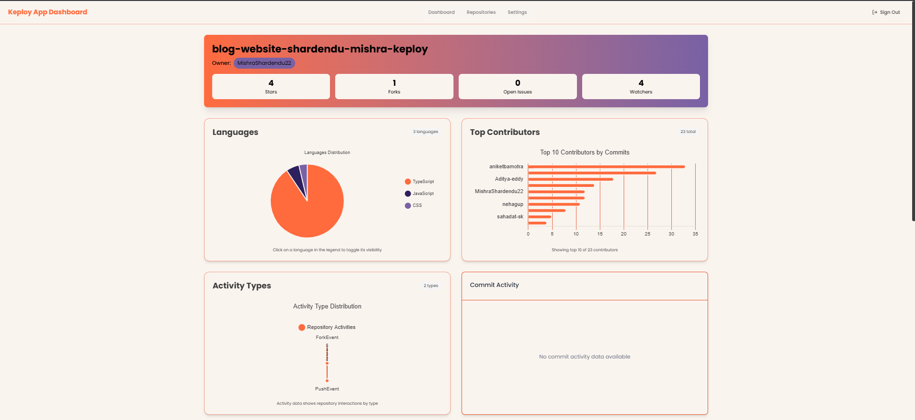

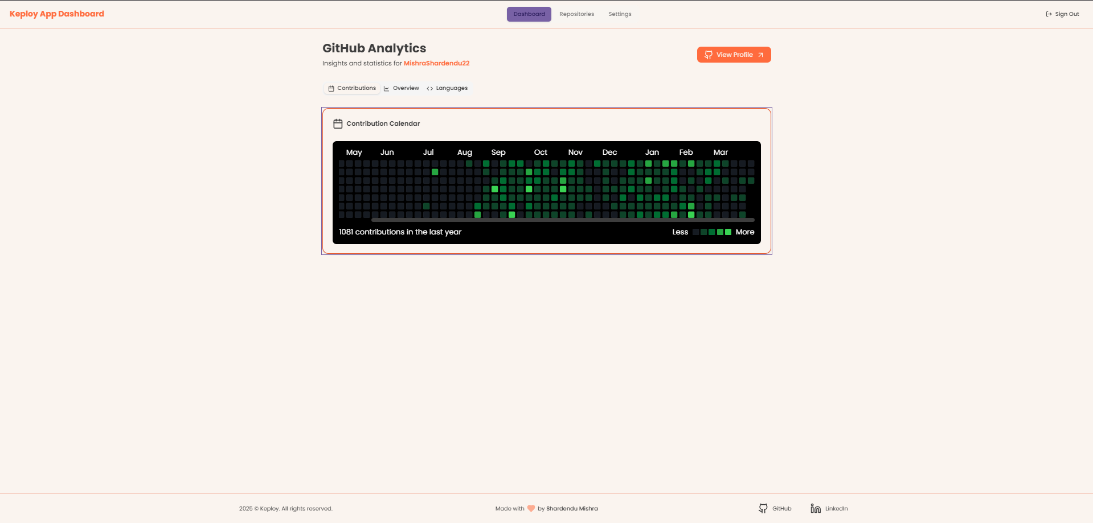 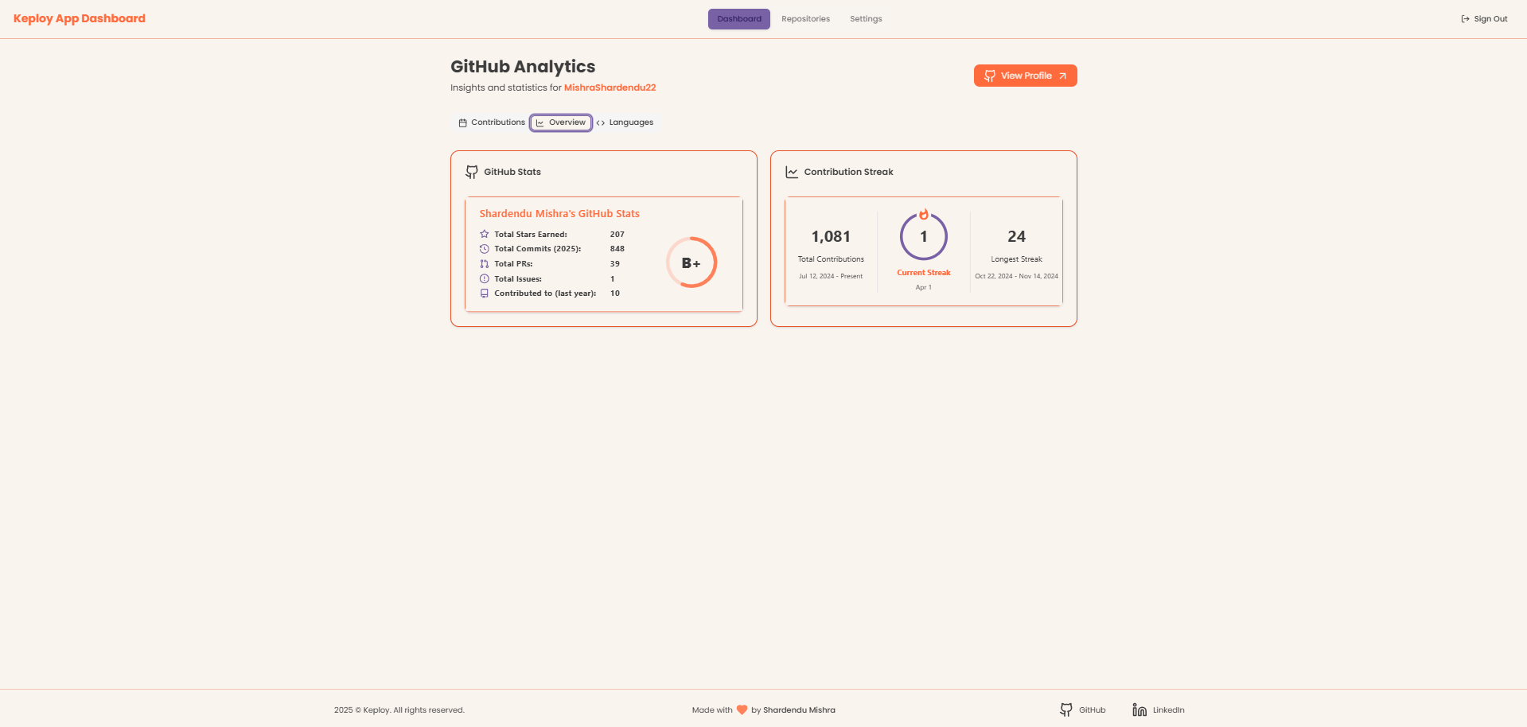

Keploy’s focus on **automated testing, observability, and seamless API mocking** excites me, as these are critical areas in modern software development. I believe contributing to this project will not only help me enhance my technical skills but also allow me to make a meaningful impact in open-source development.

**3. Open-Source Contributions** Although I haven't formally participated in open-source programs, I have contributed to:

* An **educational platform** developed by senior engineers: [Vidkarya](https://vidkarya.vercel.app/) (Career Page).
* My **college’s website**: [IIIT Dharwad Website](https://iiitdwd.ac.in/).
* Keploy’s repository: [PR #99 on Keploy Blog](https://github.com/keploy/blog-website/pull/99).

I recently worked on solving issues in Keploy GitHub though I wasn’t able to make a lot of meaningful contributions. I found its developer community highly supportive and collaborative. This, combined with the opportunity to gain hands-on experience in real-world projects, motivates me to contribute further through GSoC.

**Commitment**

**1. Are you planning any vacations during the GSoC period?**

I do not plan to take any vacations during the GSoC period, as I view this time as a critical opportunity to invest in my professional growth, thus, I will be fully dedicated throughout the GSoC period, channeling my established full-stack expertise to deliver high-quality solutions.

**2. How many classes are you taking during the GSoC period?**

* From April 19 to the first week of August, I am on break from college, thus I’ll be fully dedicated to GSoC during this period.
* From August to mid-November, my flexible schedule includes only a few classes per day, leaving ample time to focus on the GSoC project.

**3. Do you have any other employment during the GSoC period?**I am engaged in a remote part-time internship until the second week of May. After that, I will be fully dedicated to the project.

**4. How many hours per week do you expect to work on the project and what hours do you tend to work?**

While my schedule is flexible and can be extended as project demands require, I am committed to dedicating at least 40–45 hours per week, with regular working hours from 2:00 PM to midnight or until 2:00 AM IST.

**Contributions so far**

● **PRs Merged and Unmerged:**

* [PR #99 on Keploy Blog Website](https://github.com/keploy/blog-website/pull/99) *(Unmerged)*
* [PR #175 on Keploy Website](https://github.com/keploy/website/pull/175) *(Unmerged)*

● **Issues and Bugs Found:**

* No issues or bugs have been reported.

● **Documentation Contributions:**

* No documentation contributions have been made.

● **Other Contributions:**

* Suggest switching from PNG/JPG to WEBP for faster image loading and improved site performance.
* <https://github.com/keploy/keploy/issues/2554> (Suggestion for the feature implementation)

## **Proposal**

### **Overview**

### **Provide a Brief Overview of Your Proposed Solution and the Objectives You Want to Achieve with Your Chosen Project**

### The proposed solution is a real-time, interactive web dashboard that enables users to monitor their GitHub activity, including pull requests, commits, merges, and repository contributions. This dashboard will provide customizable analytics, data visualizations, and insights to help developers track their contributions and improve their workflow.

### **Objectives:**

### **Real-Time GitHub Activity Tracking:** Show live updates on pull requests, commits, and repository activities.

### **Customizable Dashboard:** Let users filter, sort, and visualize GitHub stats with interactive charts.

### **Scalable & High-Performance System:** Build a modular architecture with optimized APIs and caching for efficiency.

### **AI-Driven Insights:** Leverage advanced models to provide trend analysis and detailed explanations.

### **Secure Authentication & Access Control:** Use OAuth-based GitHub login for safe and reliable API access.

### **Seamless Real-Time Updates:** Implement WebSockets to push updates without requiring page reloads.

### 

### 

### **Please Include Programming Languages, Tools, and Technologies You Plan to Use**

### **Programming Languages:**

### **Golang** - Backend development and API services.

### **TypeScript & JavaScript** - Frontend development with improved type safety and maintainability.

### **Frontend Technologies:**

### **Next.js** - Server-side rendering and optimized frontend performance.

### **ShadCN & Tailwind CSS** - Modern, responsive UI design.

### **Chart.js & Recharts** - Real-time data visualization.

### **WebSockets** - Real time updates for charts and metrics.

### **Zustand / Redux** - State management for seamless data handling.

### **Backend Technologies:**

### **Go Fiber** - High-performance Golang framework for building REST APIs.

### **Auth.js** - Secure GitHub authentication.

### **Soket.IO** - Real-time communication for instant updates.

### **Axios & Fiber HTTP Client** – Fetching and managing data from the GitHub API efficiently.

### **Database & Storage:**

### **MongoDB** - NoSQL database for fast and scalable storage.

### **Redis** - Caching GitHub API responses to optimize performance and reduce API rate limits.

### **APIs & Integrations:**

### **GitHub API** - Fetching repository and user activity data.

### **Lighthouse** - Performance auditing and optimization.

### **Grafana & Prometheus** - Monitoring application performance and analytics.

### **Postman** - API testing and debugging.

### **Additional Technologies (Optional Enhancements):**

### **AI-Driven RAG Model** - Generating automated explanations and insights from GitHub activity data.

### **gRPC** - Efficient inter-service communication to enhance backend performance.

### 

### 

### 

### 

### **Detailed**

### The proposed solution is an interactive web application that provides real-time tracking and analytics of GitHub activity, enabling users to monitor their repository contributions, commits, pull requests, and more through a dynamic dashboard.

### The frontend will be built with Next.js to ensure a responsive, server-rendered experience, while the backend will be developed in Golang using Go Fiber for high-performance API services.

### Secure authentication is achieved using Auth.js combined with GitHub OAuth, ensuring that user data is accessed safely and reliably. Data is fetched directly from the GitHub API, and Redis will be employed for caching to improve performance and reduce API load. Real-time updates are facilitated through Socekt.IO, which will allow the dashboard to instantly reflect new data.

### For data visualization, libraries such as Chart.js and React Charts will be used, complemented by Grafana for advanced performance monitoring. An AI-driven RAG model is also being explored to provide contextual insights and trend analysis, adding an extra layer of value for users. Detailed design documents including [**Wireframes**](https://github.com/MishraShardendu22-CP/Draw.io_ShardenduMishra/blob/main/GSoC_wireframe.md), a project roadmap, and flowcharts are available for review.

### **Supporting Points**:

### **Frameworks & Technologies:**

### **Frontend:** Next.js for server-rendered, responsive UI and for building interactive components.

### **Backend:** Golang with Go Fiber for efficient REST API development.

### **Authentication & Security:**

### **Auth.js & GitHub Oauth:** Secure user authentication and controlled access to data.

### **Data Integration & Caching:**

### **GitHub API:** For retrieving comprehensive repository and activity data.

### **Redis:** For caching frequent requests to optimize performance.

### **Real-Time Updates:**

### **WebSockets:** To push live updates to the dashboard without requiring page refreshes.

### **Data Visualization:**

### **Chart.js & React Charts:** For interactive, dynamic charts.

### **Grafana:** For in-depth monitoring and performance visualization.

### **Advanced Enhancements:**

### **AI-driven RAG Model:** To generate contextual insights and trend analyses, enhancing the user's understanding of their activity.

### **Supplementary Information:**

* + **Prototype:** [**Live Application**](https://keploy-dashboard-shardendu-mishra-gsoc.vercel.app/)
  + **Demo Video:** [**Live Demo**](http://loom.com/share/dee0f5f41ba242cca0c3e43f1fc198aa?sid=e228765b-fa4b-4f3b-bd79-7a790ad453ad)

### **Wireframe:** [**WireFrames Documentation**](https://github.com/MishraShardendu22-CP/Draw.io_ShardenduMishra/blob/main/GSoC_wireframe.md)

### **Project Roadmap:** [**Notion Todo Roadmap**](https://www.notion.so/GSoC-1c5a76fcf2f98076ad1afd3c43ad3ba8)

### **Flowchart:** [**GSoC App Metric Flowchart**](https://raw.githubusercontent.com/MishraShardendu22-CP/Draw.io_ShardenduMishra/refs/heads/main/GSoC_AppMetric.jpg)

* + **Prototype SRS:** [**Software Requirement Specification**](https://docs.google.com/document/d/1wguduX0S8ePKvgzWP0mF0ActUn5WM7yqVhEgUjo0Clc/edit?usp=sharing)
  + **Prototype UI Design:** [**UI Figma Designs**](https://www.figma.com/design/hAmLTnuPrZ67iN66sfw8O3/Keploy-ShardenduMishra-GSoC-25?node-id=0-1&t=1nAoxTVRJI6OsxH0-1)
  + **Sample DB Schema:** [**Database Schema**](https://github.com/MishraShardendu22-CP/Draw.io_ShardenduMishra/blob/main/database.schema.sample.go)

### **Project Plan**

I plan to use my summer efficiently by leveraging my full-stack expertise and managing my time effectively to meet targets for both pre and post - Midterm phases, consistently staying ahead of schedule.

During the pre-Midterm phase, my primary focus will be on establishing a solid project foundation. This includes gathering detailed requirements, finalizing system specifications, and developing the initial design. I will complete the [**Software Requirement Specification (SRS)**](https://docs.google.com/document/d/1wguduX0S8ePKvgzWP0mF0ActUn5WM7yqVhEgUjo0Clc/edit?usp=sharing) and [**Database Schema**](https://github.com/MishraShardendu22-CP/Draw.io_ShardenduMishra/blob/main/database.schema.sample.go), create detailed [**Wireframes**](https://github.com/MishraShardendu22-CP/Draw.io_ShardenduMishra/blob/main/GSoC_wireframe.md)and [**UI Figma Designs**](https://www.figma.com/design/hAmLTnuPrZ67iN66sfw8O3/Keploy-ShardenduMishra-GSoC-25?node-id=0-1&t=1nAoxTVRJI6OsxH0-1), and develop an enhanced prototype of the web application to validate key functionalities. I will engage proactively with mentors at every critical milestone to ensure the project remains on track and aligned with their expectations.

In the post-Midterm phase, I will concentrate on completing the core software development and enhancing the application based on early testing feedback. My aim is to finalize all features well before the project deadline, allowing ample time for real user-based testing and refinements. Regular check-ins with mentors will continue throughout this phase to gather feedback and adjust the development roadmap as needed. This phased and mentor-supported approach is designed to ensure the final product is polished, fully functional, and aligned with the project’s vision upon release.

To sum-up my points -

**Pre-Midterm:**

* Finalize [**Software Requirement Specification (SRS)**](https://docs.google.com/document/d/1wguduX0S8ePKvgzWP0mF0ActUn5WM7yqVhEgUjo0Clc/edit?usp=sharing)and [**Database Schema**](https://github.com/MishraShardendu22-CP/Draw.io_ShardenduMishra/blob/main/database.schema.sample.go).
* Develop detailed [**Wireframes**](https://github.com/MishraShardendu22-CP/Draw.io_ShardenduMishra/blob/main/GSoC_wireframe.md) and [**UI Figma Designs**](https://www.figma.com/design/hAmLTnuPrZ67iN66sfw8O3/Keploy-ShardenduMishra-GSoC-25?node-id=0-1&t=1nAoxTVRJI6OsxH0-1).
* Build a small, enhanced prototype for initial testing.
* Set up core backend APIs and basic frontend components.

**Post-Midterm:**

* Complete full software development and integrate all features.
* Conduct extensive user-based testing and gather feedback.
* Refine and optimize the application for performance and usability.
* Finalize deployment preparations and documentation for a robust release.

### **Project Plan - Preliminary Plan:**

During the Community Bonding Period (May 8 – June 1), my primary goal is to thoroughly understand the existing codebase and discuss with my mentors the most effective strategy for implementing the project. This phase will be dedicated to upskilling, familiarizing myself with current systems, and refining the project plan based on mentor insights. The deliverable for this period is a well-defined implementation plan that aligns with both the project's requirements and the mentors' recommendations.

**Key Deliverable:**

* Achieve a complete understanding of the existing codebase and finalize a concrete implementation plan in consultation with mentors.

**Timeline for the Understanding of Database and Consultation with Mentors:**

* **Start Date:** May 8
* **End Date:** June 1

|  |  |  |  |
| --- | --- | --- | --- |
| Week Number | Start Date | End Date | Tasks to be completed |
| Week 1 | June 2 | June 8 | **Requirement Analysis & Research**: Conducted an in-depth study of Keploy's existing architecture and how the dashboard will integrate with its ecosystem. |
| Week 2 | June 9 | June 15 | **Backend Schema & UI/UX Planning**: Defined the data models, API endpoints, and authentication strategies. Begin UI wireframing. |
| Week 3 | June 16 | June 22 | **Frontend & Backend Prototyping**: Implemented a basic UI layout with placeholder components. Develop initial API routes with mock data. |
| Week 4 | June 23 | June 29 | **Core Feature Development**: Implemented real-time data fetching using GitHub API, integrated WebSocket’s for live updates. |
| Week 5 | June 30 | July 6 | **Feature Refinement & Performance Optimization**: Implement caching (Redis), optimize API response handling, conduct UI responsiveness testing. |
| Week 6 | July 7 | July 13 | **Finalization for Midterm Evaluation**: Fix bugs, write documentation, conduct usability tests, prepare midterm reports. |
| Submission | July 14 | July 18 | **Midterm Evaluation Submission**: Submit the deliverables including the functional prototype, documentation, and mentor feedback incorporation. |

**Artifacts and Diagrams:**

1. **Workflow Flow Chart:**

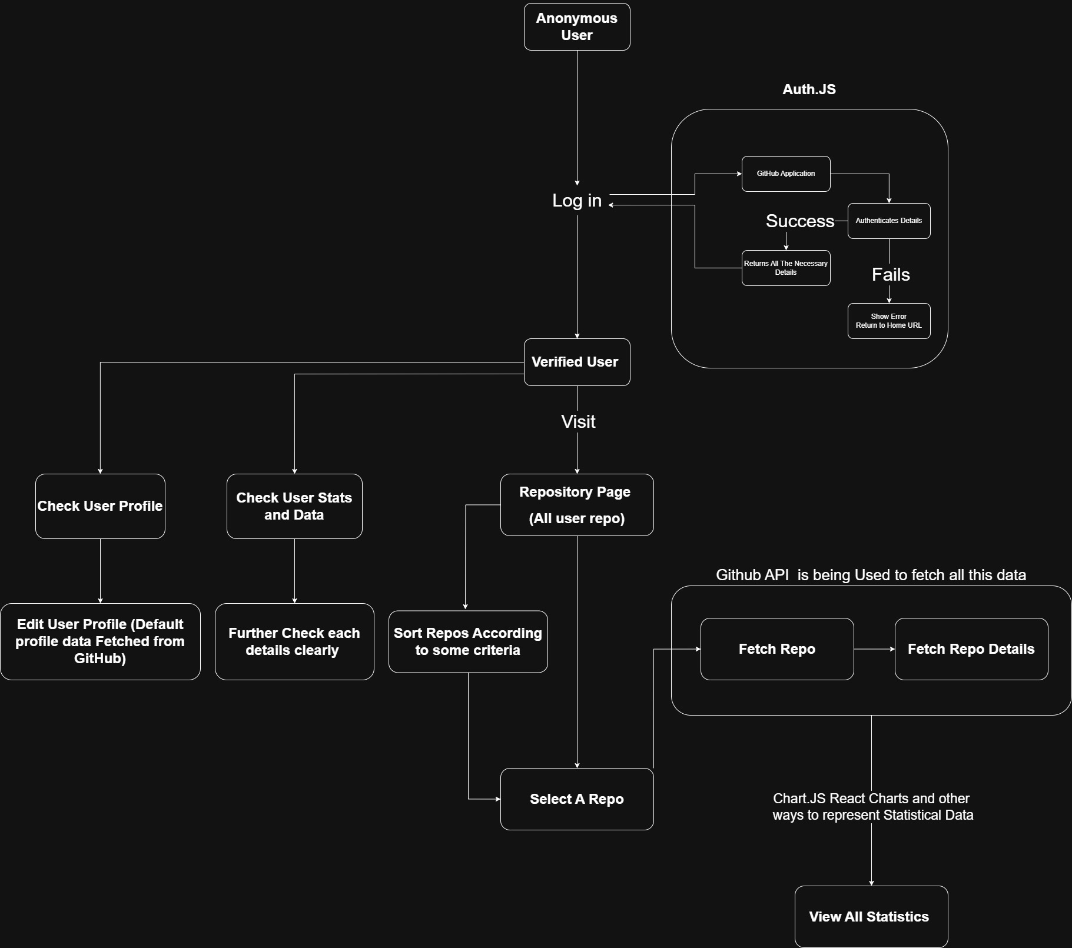

1. **Database Schema:** [**Sample Go File**](https://github.com/MishraShardendu22-CP/Draw.io_ShardenduMishra/blob/main/database.schema.sample.go)
2. **GitHub Repository:** [**Prototypes GitHub Repository With All Code Samples**](https://github.com/MishraShardendu22/GSOC-Proposal-App-Dashboard-Shardendu-Mishra-Keploy)
3. **Software Requirement Specification:**  [**Software Requirement Specification (SRS)**](https://docs.google.com/document/d/1wguduX0S8ePKvgzWP0mF0ActUn5WM7yqVhEgUjo0Clc/edit?usp=sharing)

**Major Milestones**

1. **Completion of Project Foundation & Initial Prototype** **Date:** June 22, 2025
   * Finalize SRS, backend schema, UI/UX designs, and have a working prototype for review.
2. **Midterm Evaluation & Feature Completion** **Date:** July 14, 2025
   * Fully integrate frontend and backend, implement core features, and submit for midterm evaluation.
3. **Final Testing, Optimization & Submission** **Date:** August 25, 2025
   * Complete testing, apply refinements, finalize documentation, and submit the final project.

## **Additional Information**

## **1. Why do you believe you will be able to complete your project within the timeline you have provided?**

## I am confident in my ability to complete this project within the proposed timeline, given my proven track record of delivering high-quality solutions under tight deadlines. I have already developed a working prototype of the Keploy Dashboard, which you can explore here: [**Keploy Dashboard Prototype**](https://keploy-dashboard-shardendu-mishra-gsoc.vercel.app/) and a [**Live Demo of the application Here**](http://loom.com/share/dee0f5f41ba242cca0c3e43f1fc198aa?sid=e228765b-fa4b-4f3b-bd79-7a790ad453ad)**.** This prototype aligns directly with the project’s objectives, demonstrating my ability to design, build, and iterate efficiently.

## With extensive experience in full-stack development, I have successfully delivered multiple projects that integrate frontend and backend technologies seamlessly. In my recent internship, I developed a full-stack web application while adapting to evolving requirements, ensuring timely delivery without compromising on quality. My ability to handle complex technical challenges and optimize performance makes me well-equipped to execute this project effectively.

### **2. What prior experiences or projects can you share that demonstrate your ability to complete this project successfully?**

### I have worked extensively on real-time data analytics dashboards and interactive applications, demonstrating my ability to build scalable and efficient full-stack solutions. A comprehensive list of my 15+ full-stack projects can be found on my GitHub: [**Projects Made**](https://github.com/MishraShardendu22/ProjectsMade)**.**

### One of my notable achievements includes winning a hackathon, where I successfully developed a fully functional solution under tight time constraints, showcasing my ability to think on my feet and execute ideas rapidly. You can view the details here: [**Hackathon Winner – Google Drive**](https://drive.google.com/file/d/1pd3G1ljCE9PXkZepPJt26N16Z6qQ04XX/view?usp=sharing)**.**

### Beyond hackathons, my real-world experience in developing production-grade applications has reinforced my ability to meet deadlines while ensuring high-quality code and seamless user experience. These experiences have equipped me with the technical and problem-solving skills necessary to deliver this project successfully.

### **3. Have you applied to any other GSoC projects or organizations? If yes, which one would you prefer and why?**

### No, I have not applied to any other GSoC projects or organizations. I strongly believe in dedicating my full attention and effort to a single project to ensure its success.

### I have carefully chosen this project because it aligns perfectly with my expertise in full-stack development, real-time data visualization, and performance optimization. More importantly, I am passionate about building tools that provide meaningful insights through analytics, making this project an ideal match for my skills and interests.

### **4. Is there anything else you would like to share that may be relevant to your application?**

### Beyond my technical skills, I am highly dedicated, proactive, and results-driven. Whether it's meeting tight deadlines, winning hackathons, or managing multiple project requirements, I consistently push myself to achieve the best outcomes.

### I currently lead my college’s **Web Development Club**, where I have spearheaded multiple impactful projects, including an **automation system for my college website**. You can check out the project here: [**College Website Automation - GitHub**](https://github.com/Velocity-IIITDWD/content.iiitdwd.ac.in)**.**

### Additionally, I am the lead of **Team Parashuram**, a group that has won multiple hackathons and earned several accolades. You can explore our projects here: [**Team Parashuram - GitHub**](https://github.com/Team-Parashuram)**.**

### Beyond technical contributions, I have organized events, led recruitment drives, and mentored junior students, refining my leadership and communication skills. These experiences have strengthened my ability to collaborate effectively, manage projects efficiently, and articulate complex ideas with clarity.

### My timeline for this project has been meticulously planned, factoring in both the complexity of the tasks and my ability to deliver high-quality work on schedule. I am fully committed to making meaningful contributions to this project and ensuring its successful execution.

### **Q. What to expect from your mentor (and what your mentor expects from you)**

**If you are selected to GSoC with Keploy, you can expect the following:**

● We recognize that the goals may change during the project, and the mentors will accept modifications to the goals at any time. But they are also expecting to see the reasonable effort go into the initial project timeline. Any changes to your goals or plan are expected to be immediately communicated to your mentor.

● The scope of the project might change to fit in the duration of GSoC

● Your mentor will establish a weekly, synchronous check-in with you.

● In addition to that check-in, your mentor will discuss with you any specific status updates or any other regular communication they expect from you as well as which methods they prefer for documentation and collaboration (Google Docs, wiki, etc.).

● The project plan and timeline you outlined in your application will also form a significant part of your midterm and final evaluations.

## **Q. What to expect from GSoC at Keploy?**

**We want you to have a productive, engaging summer. To that end:**

● We will schedule several events throughout the summer where you can interact with other GSoC students and the rest of the Keploy community.

● You will have the opportunity to present your work to this broader community.